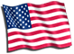

United States History
- Home
- Chronological Eras
- Information Tables
- Maps
- History Quizzes
- Glossary
- Blog
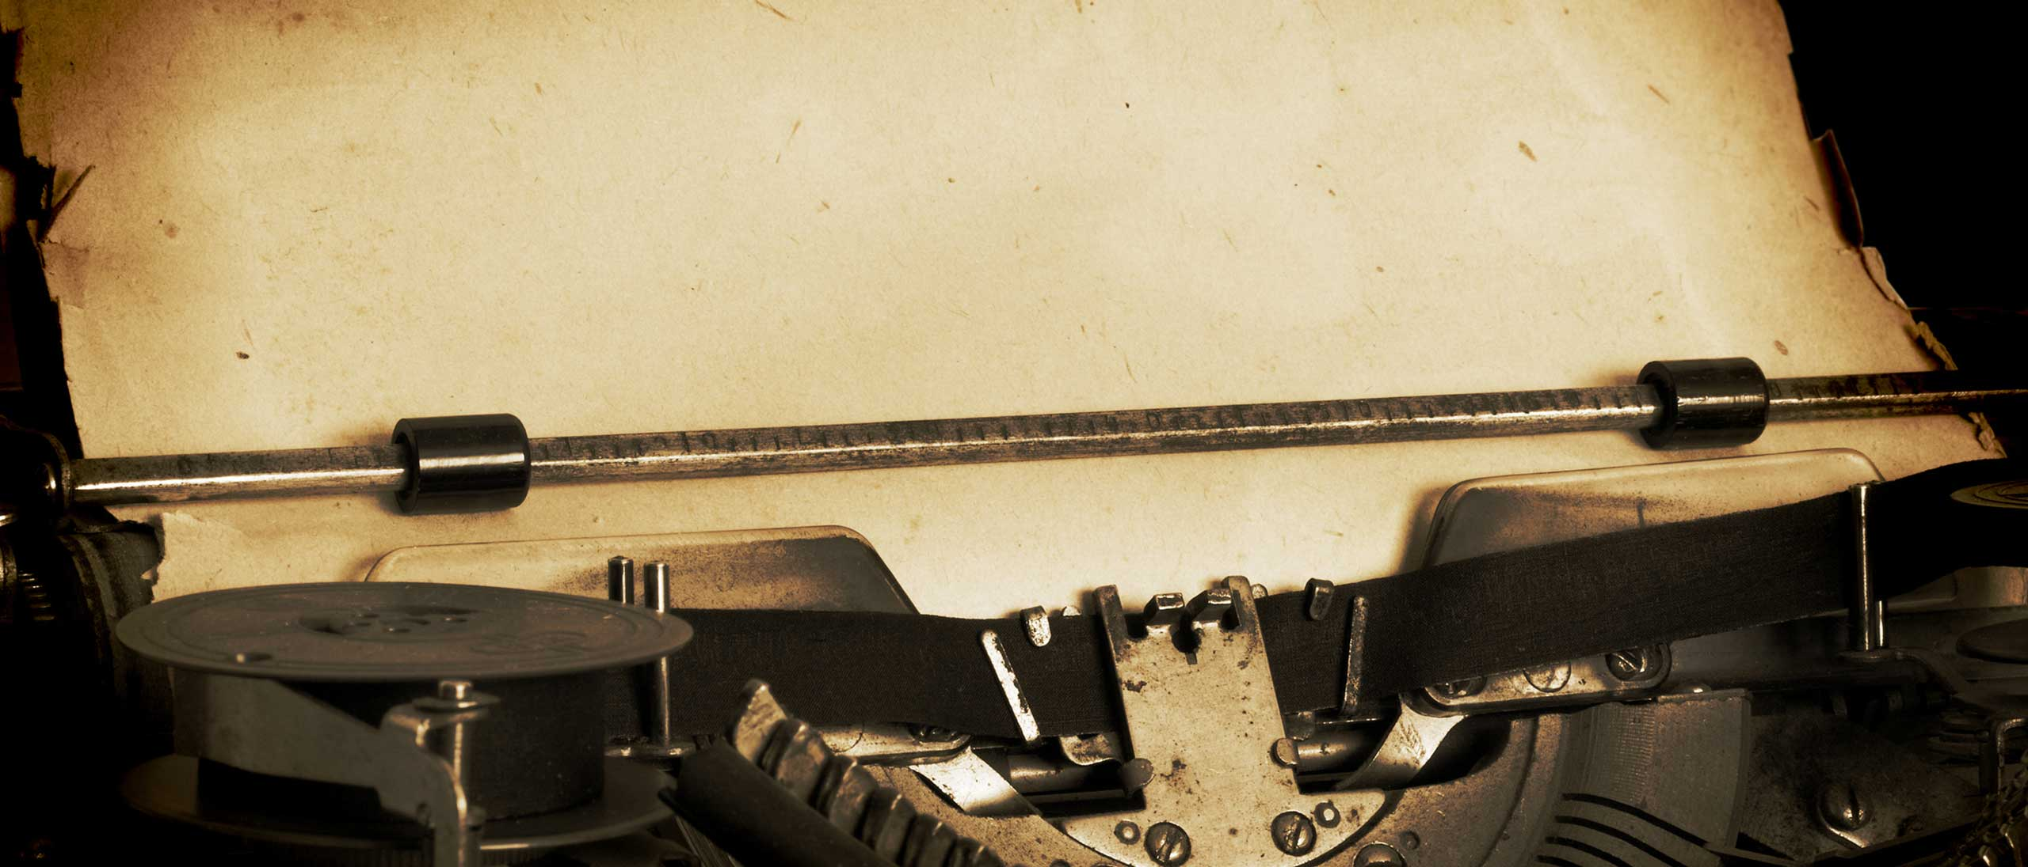

World War II
Introduction
World War II was the mightiest struggle humankind has ever seen. It killed more people, cost more money, damaged more property, affected more people, and caused more far-reaching changes in nearly every country than any other war in history. The number of people killed, wounded, or missing between September 1939 and September 1945 can never be calculated, but it is estimated that more than 55 million people perished.
More than 50 countries took part in the war, and the whole world felt its effects. Men fought in almost every part of the world, on every continent except Antarctica. Chief battlegrounds included Asia, Europe, North Africa, the Atlantic and Pacific oceans, and the Mediterranean Sea.
The United States hoped to stay out. Drawing on its experience from World War I, Congress passed a series of Neutrality Acts between 1935 and 1939, which were intended to prevent Americans becoming entangled with belligerents. Americans in general, however, while not wanting to fight the war, were definitely not neutral in their sympathies and the acts were manipulated, to the frustration of genuine isolationists, to lend more support to the Allies than the Axis.
Historians do not agree on the exact date when World War II began. Most consider the German invasion of Poland on September 1, 1939, to be the beginning of the war. Others say it started when the Japanese invaded Manchuria on September 18, 1931. Others even regard World War I, which culminated in the Peace with the Central Powers in 1921 and World War II as parts of the same conflict, with only a breathing spell in between.
War officially began on September 1, 1939, when Germany attacked Poland. Germany then crushed six countries in three months — Denmark, Norway, Belgium, Luxembourg, The Netherlands, and France — and proceeded to conquer Yugoslavia and Greece.
Japan`s plans for expansion in the Far East led it to attack Pearl Harbor in December 1941, bringing the United States into the war. By early 1942, all major countries of the world were involved in the most destructive war in history.
World War II would go down in the history books as bringing about the downfall of Western Europe as the center of world power, leading to the rise of the Union of Soviet Socialist Republics (U.S.S.R.), setting up conditions leading to the Cold War, and opening up the nuclear age.
Causes of the war
The Great Depression crippled the economies of Europe and the United States. That, combined with the outcome of World War I, led to major repositioning of world power and influence. That was fertile ground for the emergence of various forms of totalitarian governments in the Soviet Union, Japan, Italy, and Germany, as well as other countries. Many countries had liberal democratic governments following World War I, but dictatorship developed during the 1920s and 1930s, which destroyed democratic rights.
Many historians trace the roots of World War II to the Treaty of Versailles and other peace agreements that followed World War I. The Germans found it easy to blame the harsh Treaty of Versailles for their troubles.
Germany set up a republican form of government in 1919. Many Germans blamed the new government for accepting the hated treaty. People who could not find jobs began to drift into the Communist and National Socialist parties. As the government lost power, Adolf Hitler and his National Socialist or Nazi party grew stronger.
Prior to 1914, Britain, France, and Germany were the industrial and financial centers of the world. Following World War I, those countries lost their positions and the United States filled their place. America dominated the world market of food, minerals, and industry.
When the stock market crashed on October 29, 1929, the financial crisis had worldwide consequences and the reaction of nations to the dire financial straits of the Depression had a huge impact.
After World War I, Germany, Italy, and Japan — all anxious to regain or increase their power — adopted forms of dictatorship. The League of Nations was unable to promote disarmament. When Adolf Hitler came into power, he promised to end the humiliating conditions caused by German defeat in World War I.
Economic problems were among the fundamental causes of World War II. Germany, Italy, and Japan considered themselves unjustly handicapped in trying to compete with other nations for markets, raw materials, and colonies. They believed that such countries as Belgium, France, Great Britian, the Netherlands, and the United States unfairly controlled most of the world`s wealth and people. So, Germany, Italy, and Japan began to look for lands to conquer in order to obtain what they considered to be their share of the world`s resources and markets.
The Depression destroyed the market for imported silk from Japan, which had provided the country with two-fifths of its export income. Military leaders took control of the government, and in 1931, Japan invaded China, looking for more raw materials and bigger markets for her factories.
The League of Nations called a conference of 60 nations in Geneva, Switzerland, in 1932. The conference was one in a long line of disarmament conferences that had been occuring since the end of World War I.
Germany, whose military power had been severely limited by the Treaty of Versailles, announced that world disarmament had to be accomplished, or Germany would rearm and achieve military equality. France refused to disarm until an international police system could be established.
The conference adjourned temporarily and by the time it was back in session, Hitler had become chancellor of Germany and was already preparing to rearm. Germany withdrew from the conference, which ended in failure, without any hope for disarmament.
America prepares for war
After the war began in Europe in 1939, people in the Americas were divided on whether their countries should take part or stay out. Most Americans hoped the Allies would win, but they also hoped to keep the United States out of war. The isolationists, wanted the country to stay out of the war at almost any cost. Another group, the interventionists, wanted the United States to do all in its power to aid the Allies. Canada declared war on Germany almost at once, while the United States shifted its policy from neutrality to preparedness. It began to expand its armed forces, build defense plants, and give the Allies all-out aid short of war.
President Franklin D. Roosevelt called upon the United States to be "the great arsenal of democracy," and supply war materials to the Allies through sale, lease, or loan. The Lend-Lease bill became law on March 11, 1941. During the next four years, the U.S. sent more than $50 billion worth of war matériel to the Allies.
In 1939, the United States had about 174,000 men in the Army; 126,400 in the Navy; 26,000 in the Army Air Corps; 19,700 in the Marine Corps; and 10,000 in the Coast Guard. At the height of its strength in 1945, the United States had six million in the Army; 3,400,000 in the Navy; 2,400,000 in the Army air forces; 484,000 in the Marine Corps; and 170,000 in the Coast Guard. In 1939, the United States had about 2,500 airplanes and 760 warships. By 1945, it had about 80,000 airplanes and 2,500 warships. The United States used draft laws to build their armed forces. The United States Selective Service Act became law on September 16, 1940. Thousands of women served in the Army`s Women`s Army Corps (WAC) and Navy equivalent WAVES, standing for Women Accepted for Volunteer Emergency Service.
Factories in the United States converted from civilian to war production with amazing speed. Firms that had made vacuum cleaners before the war began to produce machine guns. As men went into the armed forces, women took their places in war plants. By 1943, more than two million women were working in American war industries. In shipyards and aircraft plants, Rosie the riveter became a common sight. Officials discovered that women could perform the duties of eight of every 10 jobs normally done by men.
Urgent requirements for war matériel caused many shortages in consumer goods. Most governments, both Allied and Axis, had to ration the amount of consumer goods each person could use. In the United States, rationed items included meats, butter, sugar, fats, oil, coffee, canned foods, shoes, and gasoline. Congress gave the president power to freeze prices, salaries, and wages at their levels of September 15, 1942. The United States imposed a special excise tax on such luxury items as jewelry and cosmetics. The government also set up a civil-defense system to protect the country from attack. Many cities practiced "blackouts" in which cities on the Atlantic and Pacific coasts dimmed their lights. Ordinarily, the glare from their lights made ships near the shore easy targets for submarines.
Background of the Axis and Allied powers
As in World War I, the United States, Great Britian, France, and the 47 countries siding with them were known as the Allies. Japan`s attack on Pearl Harbor in 1941 brought the United States into the war on the Allied side. Every country in the Americas eventually declared war on the Axis, but only Brazil, Canada, Mexico, and the United States actually provided military forces.
The heads of government of China, Great Britian, the Soviet Union, and the United States became known as the "Big Four." During the war, the Big Four leaders conferred several times. Great Britian and the United States worked out the broad strategic outlines of the war. President Roosevelt and Prime Minister Winston Churchill agreed to concentrate on Germany first, and then Japan. They considered Germany the greater and closer enemy.
The Allies fought to perserve their countries and stabilize Europe, as well as destroy Nazism and establish democracy. The Soviet aim was to drive out the Nazis and emerge strong enough to continue communization of the world.
Germany and its six allies were known as the Axis. The Allied and Axis countries circled the globe in World War II. The Allies mobilized about 62 million men and women, while the Axis mobilized about half that number.
The goal of the Axis powers was simple. Germany intended to build up a powerful empire by occupying territory to the east and south. Then, after overrunning France, it would use air assaults to force Britian to make peace. German troops would then defeat the Soviet Union, capture the Caucasus oilfields, and implement Hitler`s plan for a European New Order.
Hitler had two aims: the first to seize all of Europe and North Africa so he could dominate the Mediterranean, and the second to wipe out Communism and eliminate the Jews. His ally, Benito Mussolini, had his own aims: domination of both the Mediterranean and the Balkans. Italy hoped to take advantage of German successes to grab territory for itself.
Japan intended to cripple the United States Pacific Fleet at Pearl Harbor, then quickly overrun Thailand, Malaya, the Philippines, and the Netherlands East Indies. It would then complete its conquest of China, and unite all East Asia under Japanese domination in a Greater East Asia Co-Prosperity Sphere. Japan had no plans for invading the United States mainland.
The European/North African Theater
In 1935, Hitler established military conscription for all German men, created an air force, and began to build submarines. The Treaty of Versailles limited Germany to a 100,000-man army, but Hitler`s army soon numbered 600,000. Hitler`s plan to seize all of Europe was set into motion on March 7, 1936, when he sent troops into the demilitarized Rhineland. That was followed by moves into Austria and Czechoslovakia, and finally, on September 1, 1939, German forces invaded Poland.
That brought a declaration of war from France and Britain. Some historians believe that the Soviet Union leadership knew in the spring or early summer of 1939 that Germany planned to invade Poland in September. Thus, the Soviet Union signed a nonaggression pact with Germany just two weeks before the attack.
The U.S.S.R. promised to remain neutral in case Germany went to war. They also made a secret aggreement to divide Poland with the Germans after the conquest. Also, despite having signed a non-agression treaty with Joseph Stalin, Hitler turned on his ally and prepared to become the master of Europe. Germany and Italy declared war on the United States on December 11, 1941.
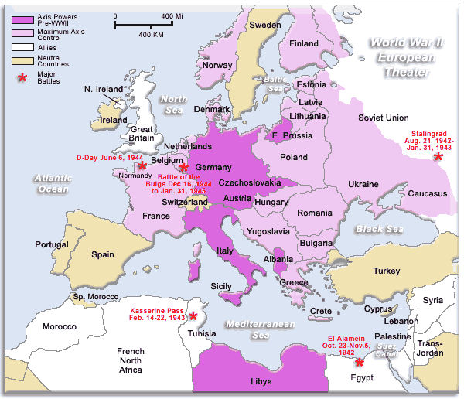
The North African Campaign, also known as the Desert War, took place in the North African desert from 1940 to 1943. It was quite important in strategic terms, with the Mediterranean and the British African Empire at stake. It was the only theater in which the Western Allies engaged both German and Italian ground forces.
Fighting in the region began when Germany`s ally, Italy, attacked British-occupied areas. Hitler did not want British planes within striking distance of his one major oil source, the Ploiesti fields in Romania, and in November 1940, he prepared his soldiers to join in the fight.
A decisive battle held in the North African campaign was the Battle of Tunisia, or Tunisia Campaign, in which Germany and Italy fought against the Allied forces comprising primarily the United States and Britain. More than 275,000 German and Italian prisoners of war were taken.
Following seesawing control of Libya and parts of Egypt, British Commonwealth forces succeeded in pushing the Axis back. The dispersion of the Axis forces throughout Europe during this time was an important reason why the Allies were able to gain the upper hand in North Africa.
Hitler was preoccupied with the Russian front and many divisions of the German army were already committed to it. North Africa was essentially used as a springboard for the Allied invasion of Sicily in July 1943 and Italy in September of the same year.
Along with worldwide domination, Hitler also aimed to rid the world of various ethnic, religious, national, and secular groups. The Holocaust began in 1941 and continued until 1945. The goal of the Nazis was to attempt, on an industrial scale, to assemble and exterminate as many people as possible. Concentration camps were established and mass executions carried out.
The Jews of Europe were the main targets, but Hitler also targeted Poles, Slavs, gypsies, the disabled, and gay men. By the end of the war, approximately six million people had been killed by the German Gestapo or the SS.
The Battle of Britain, which lasted from July 10 to October 31, 1940, was the first major battle of World War II. It was also one of the turning points in the war, because the British showed that they could defeat the Luftwaffe, or German air force. The battle was unique, in that it was the only battle ever fought entirely in the air, even to this day.
The Battle of Normandy was fought between invading American, British, and Canadian forces, and German forces occupying Western Europe. Preparations for the invasion began early in 1943, when the Allies set up a planning staff. Roosevelt and Churchill selected General Dwight D. Eisenhower as supreme commander of the Allied Expeditionary Force.
On June 6, 1944, 160,000 Allied troops and 30,000 vehicles landed along a 50-mile front of fortified French coastline and began fighting on the beaches of Normandy. It was to be known as D-Day. The invasion, code named Operation Overlord, remains the largest seaborne invasion in history.
The Battle of the Bulge, which began in December 1944, was so named because of the bulging shape of the front on a map. The battle was the last major German offensive on the Western Front during World War II. It is the largest battle the United States Army has fought to date.
In its entirety, the Battle of the Bulge was the worst — in terms of losses — for the American Forces during World War II, with more than 80,000 American casualties.
Late in April 1945, the head of the German home guard and dreaded Gestapo, Heinrich Himmler, tried to negotiate a peace with Great Britain and the United States. Adolf Hitler committed suicide in Berlin on April 30. The Allies demanded that German troops on all fronts surrender.
Early in the morning on May 7, Col. General Alfred Jodl of the German high command entered Allied headquarters in Reims, France, and signed the terms of unconditional surrender. Lt. General Walter B. Smith, Eisenhower’s chief of staff, signed for the Allies. After five years, eight months, and seven days, the European phase of World War II ended.
The Pacific Theater
The war in the Pacific essentially began on September 18, 1931, when Japan invaded Manchuria, which was known for its natural resources. The Japanese thought that from Manchuria, they could go on to control all of northern China. After Japan had established dominance in China, it could expand elsewhere. The Great Depression, Japan`s population explosion, and the need to find new resources and markets to continue as a first-rate power, were other causes of the invasion.
The Japanese struck at a time when most countries were more concerned with the depression than with an invasion in far-off China. The United States introduced a policy of non-recognition, declaring that it would not recognize Japan`s conquest.
The League of Nations did nothing but condemn Japan formally. Therefore, many consider the invasion of Manchuria as the real start of the war because aggression was not suppressed.
Since 1937, Japan had been buying cotton, gasoline, scrap iron, and aircraft equipment from the United States. After the “undeclared war” between Japan and China began in 1937, most Americans sympathized with the Chinese.
In 1938, this led the United States to place an embargo on exporting aircraft to Japan. The government also froze all Japanese assets in the United States. Relations between Japan and the United States became increasingly tense in the fall of 1941.
The Japanese Army and Navy came up with a plan to bomb Pearl Harbor and invade Thailand, the Malay peninsula, and the Philippines. About 7:55 a.m. on December 7, 1941, while negotiations were taking place between Japanese and American diplomats, the Japanese air force and navy attacked the American naval base at Pearl Harbor in Hawaii.
More than 2,300 Americans were killed and the the U.S. Pacific Fleet was crippled. Roosevelt gave a speech to a stunned Congress, in which he said that December 7 was "a date which will live in infamy." The United States entered the war against Japan, and would now also have the opportunity to move against Hitler in Europe by aiding the British — this time with forces.
Within a few hours of attacking Pearl Harbor, Japanese bombers struck at American bases on the islands of Guam, Midway, and Wake. Japanese forces advanced through the thick jungles of the Malay Peninsula. They continued their expansion and soon overran Singapore, New Britain, the Admiralty and Solomon Islands, the Philippines, and Manilla.
Just a few short months after the attack on Pearl Harbor, a fleet of 16 B-25 army bombers, led by Lt. Colonel Jimmy Doolittle, took off from the carrier Hornet, about 650 miles from Honshu, Japan. The bombers hit Tokyo and other cities. The raid stunned the Japanese, because they had believed that Allied planes could never reach their homeland.
Fifteen of Doolittle’s planes crashed when they ran out of fuel and could not reach bases in China. The Chinese underground helped Doolittle and 63 of his fliers to escape. Throughout the war, Doolittle was known as the "Master of the Calculated Risk."
The Doolittle raid helped convince the Japanese that they would have to expand their defense boundaries. Having conquered nearly all of Southeast Asia in just a few short months, Japan planned to seize Port Moresby in southeastern New Guinea.
They hoped to cut Allied shipping lanes to Australia, and perhaps even invade that country. But a U.S. task force intercepted a Japanese fleet headed toward Port Moresby in the Coral Sea. The Battle of the Coral Sea ensued, and the two forces fought a four-day battle from May 4 to 8, in which aircraft did all the fighting.
It was the first battle in which aircraft carriers attacked each other, and the first naval battle in which neither side`s ships sighted the other. The battle was an important Allied strategic victory, which blocked Japan’s push south-eastward.
The most important objectives in Japan’s resumed offensive were the capture of Midway Island, which lies 1,000 miles northwest of Hawaii, and of the Aleutian Islands, west of the Alaska mainland. Japan hoped that by seizing Midway, they could draw the Pacific Fleet away from Hawaii.
Before Pearl Harbor, the United States scored one of its greatest victories by cracking Japan’s secret code. That enabled the Pacific Fleet to know in advance about Japan’s plans for attack. On June 4, 1942, aircraft from the 100-ship Japanese fleet began blasting Midway Island, which was home to the closest remaining U.S. base to Japan.
At the end of the two-day battle, Japan had lost four carriers and a major part of its air strength. Battle of Midway proved to be one of the decisive victories in history and was the turning point of the Pacific Campaign. It ended Japanese threats to Hawaii and to the United States, and also stopped the expansion of the Japanese Empire in the Pacific.
The Allies` goal was to capture or neutralize Rabaul, an important enemy base on New Britain Island, north of Australia. They planned an invasion of the nearby Solomon Islands, while other Allied forces approached Rabaul by way of New Guinea. On August 7, 1942, the Allies began their first offensive action in the Pacific.
The fighting was some of the most severe of the war, and control of the island seesawed for several months. During that time, the Allies perfected the technique of amphibious warfare - air, land, and sea forces working together as a team. In the Solomons, the Allies fought the first of many jungle campaigns.
Allied strategists believed that the central Pacific fortress of Japan could be cracked. They did not intend to seize each island separately. This would be too costly and take too long. Instead, they decided on a plan of island hopping, or seizing key islands from which to attack the next target, bypassing other targets.
The Gilbert Islands were selected as the first major objective in the island-hopping campaign. In many instances the Japanese had studded the islands with barricades, concrete pillboxes, gun emplacements, and bombproof underground shelters. They had been ordered to resist to the very end. Of the 3,000 enemy troops and 1,800 civilian laborers on the island, the marines captured only 147 Japanese and Koreans alive. The U.S. suffered 3,110 casualties in one of the war’s most savage battles.
The Battle for Leyte Gulf was the biggest naval engagement in history from the standpoint of naval tonnage involved. The battle was a decisive victory for the United States. At the end of the battle, on October 26, Japan had lost three battleships, four carriers, 10 cruisers, and nine destroyers. In desperation, the Japanese began to strike back with Kamikazes, or suicide planes.
Enemy fliers deliberately crashed their aircraft on Allied warships, knowing that they would be killed. Allied soldiers also learned the fanatical code of bushido, which requires Japanese soldiers to fight to the death. The Japanese believed that surrender meant disgrace, and often preferred suicide to capture.
China became isolated from most of the world when the Japanese cut the Burma Road, which was about 700 miles long and constructed through rough mountain country. It was a remarkable engineering achievement undertaken by the Chinese after the start of the Sino-Japanese War in 1937, and completed in just one year. It was used to transport war supplies.
Traffic increased in importance to China after the Japanese took control of the Chinese coast and Indochina. After the Japanese cut the road, supplies could come only through the air. The U.S. Air Transport Command flew the dangerous 500-mile route, known as the Hump, over the Himalayan Mountains.
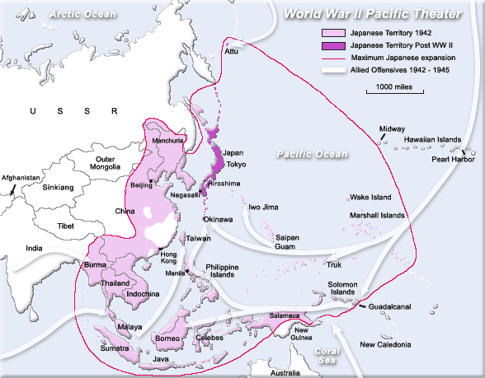
Allied strategy to end the war called for an invasion of Japan with the code name Operation Olympic. Allied warships would continue to raid Japanese shipping and coastal areas, and Allied bombers would increase their attacks. Air attacks by long-range B-29 bombers had begun on June 15, 1944, from bases in China.
Throughout the summer of 1944, the U.S. 20th Air Force raided Japan, Formosa, and Japanese-held Manchuria, about once a week. The Army Air Force flew more than 15,000 missions against 66 major Japaneses cities, and dropped more than 100,000 tons of incendiary bombs.
The Allies held such superiority in the air that early in July 1945, General Carl Spaatz, commander of the U.S. Army Strategic Air Forces in the Pacific, publicly announced in advance the names of cities to be bombed.
In July 1945, the heads of government in Britain, Soviet Union and the United States conferred and were told that Japan was willing to negotiate a peace, but unwilling to accept unconditional surrender. An ultimatum was issued, calling for unconditional surrender and a just peace. When Japan ignored the ultimatum, the United States decided to use the atomic bomb.
The atomic bomb helped to make an invasion of Japan unnecessary. On August 6, a B-29 called the Enola Gay dropped the first atomic bomb used in warfare, on the city of Hiroshima. More than 92,000 poeple were killed or ended up missing. Three days later, an atomic bomb was dropped on Nagasaki, which killed at least 40,000.
Injuries from the two bombings were about equal to the deaths. Others would die later from radiation sickness. The Japanese realized that they were helpless if one atomic bomb could cause so much damage. On August 10, the Japanese government asked the Allies if uncondional surrender meant that Emperor Hirohito would have to give up his throne.
The Allies replied that the Japanese people would decide his fate. On August 14, the Allies received a message from Japan accepting the surrender terms, and on September 2, aboard the battleship Missouri in Tokyo Bay, the Allies and Japan signed the surrender agreement. President Harry S. Truman proclaimed September 2 as V-J Day (Victory over Japan). Three years, eight months, and 22 days after Japan bombed Pearl Harbor, World War II ended.
Representatives from 52 countries met in San Francisco in September 1951 to draw up a peace treaty with Japan. On September 8, diplomats from 49 of these countries signed the treaty. Only three countries — Poland, Czechoslovakia, and Soviet Union — opposed the terms of the pact and refused to sign.
The treaty required Japan to give up its former possessions outside its four home islands. It also gave Japan the right to rearm itself for self-defense and trade agreements.
Japan came under Allied occupation within two weeks after its surrender. General Douglas MacArthur, as supreme commander for the Allied Powers, ruled Japan during the occupation. The United States officially ended its war with Japan on April 28, 1952. With the end of the occupation, Japan signed treaties with the major Allies, allowing their troops to remain in Japan.
Aftermath
World War II brought an end to the Depression everywhere. Industries had been ignited for the production of arms and resources to equip fighting forces.
"The man behind the man behind the gun" helped win World War II. People on the home front built weapons, produced food and supplies, and bought war bonds. Many historians believe that war production was the key to Allied victory. The Allies not only mobilized more men and women in their armed forces, but also outproduced the Axis in weapons and machinery.
Scientific inventions and discoveries also helped shorten the war. The United States organized its scientific resources in the Office of Scientific Research and Development. That government agency invented or improved such commodities as radar, rocket launchers, jet engines, amphibious assault boats, long-range navigational aids, devices for detecting submarines, and more.
Scientists also made it possible to produce large quantities of penicillin to fight a wide range of diseases, as well as DDT to fight jungle diseases caused by insects.
The war solved some problems, but created many others. Germany had been the dominant power on the European continent, while Japan had held that role in Asia. Their defeat in World War II left open positions of leadership. The Soviet Union moved in quickly to replace Germany as the most powerful country in Europe and also aimed at taking Japan`s place as the dominant power in Asia.
The Communists under Mao Zedong defeated the forces of Chiang Kai-shek and took over mainland China by the fall of 1949. With China, France, and Great Britain devastated and financially exhausted by the war, the United States and the Soviet Union became the two major powers of the world.
The Allies were determined not to repeat the mistakes of World War I, in which Allies had failed to set up an organization to enforce the peace until after World War I ended. In June 1941, nine European governments-in-exile joined with Great Britain and the Commonwealth countries in signing the Inter-Allied Declaration, which called for nations to cooperate and work for lasting peace.
In 1944, an idea emerged to create a postwar international organization. The United Nations was born on October 24, 1945. Its first sessions were held the following January in London.
World War II took the lives of more people than any other war in history. Eastern Europe and East Asia suffered the heaviest losses. Germany and the Soviet Union, and the nations that had been ground between them, may have lost as much as a tenth of their populations.
World War II was the most expensive war in history. It has been estimated that the cost of the war totaled between $1 and $2 trillion, and the property damage amounted to more than $239 billion. The United States spent about 10 times as much as it had spent in all its previous wars put together. The national debt rose from $42 billion in 1940 to $269 billion in 1946.
In 1944, President Roosevelt asked the War Department to devise a plan for bringing war criminals to justice. Treasury Secretary Henry Morgenthau proposed executing prominent Nazi leaders at the time of capture and banishing others to far-off corners of the world, while German POWs would be forced to rebuild Europe.
Secretary of War Henry Stimson saw things differently, and proposed trying Nazi leaders in court. Roosevelt chose the latter. In early October 1945, the four prosecuting nations — the United States, Great Britain, France, and Soviet Union — issued an indictment against 24 men charged with the systematic murder of millions of people, and planning and carrying out the war in Europe.
Twelve trials were conducted, involving more than a hundred defendants. In addition to the individual indictments, three organizations were tried and found guilty. They were the SS, the Gestapo, and the Corps of the Political Leaders of the Nazi Party. The Nuremberg War Trials took place from 1945 to 1949.
The United States formally ended hostilities with Germany on October 19, 1951. West Germany would accept neither the division of Germany nor East Germany`s frontiers. Thus, Germany was the only Axis power that did not become a member of the United Nations.
A cold war between the Soviets and the democracies ensued. In Asia, victory resulted in the takeover of China and Manchuria by the People`s Republic of China, chaos in Southeast Asia, and a division of Korea, with the Soviets in the North and American`s in the South. Another war already lay on the horizon.
---- Selected Quotes ----
Quotes regarding World War II.
By Harry S. Truman
If we see that Germany is winning we ought to help Russia and if Russia is winning we ought to help Germany, and that way let them kill as many as possible, although I don't want to see Hitler victorious under any circumstances. Neither of them thinks anything of their pledged word.
The New York Times (24 June 1941)
- - - Books You May Like Include: ----
The Brooklyn Navy Yard by Thomas F. Berner.
Not much larger than a few city blocks (219 acres, plus 72 acres of water), the Brooklyn Navy Yard is one of the most historically significant sites i...
Philadelphia Naval Shipyard by Joseph-James Ahern.
The first government-owned navy yard in Philadelphia, the birthplace of the nation and the largest city in the young republic, was started with two do...
Lakehurst, Naval Air Station by Kevin Pace, Ronald Montgomery, Rick Zitarosa.
The naval air station in Lakehurst, New Jersey, has a rich and bittersweet history steeped in success and tainted with tragedy. The area evolved from ...
Florida in World War II Floating Fortress by Nick Wynne and Richard Moorhead.
Few realize what a vital role World War II and Florida played in each other’s history. The war helped Florida move past its southern conservative ment...
The Navy Capital of the World Hampton Roads by Amy Waters Yarsinske.
From the famous Civil War ironclads that clashed in its waters to the great battleships that gathered off Norfolk’s Sewell’s Point as part of Presiden...
Fort Monroe by Paul S. Morando, David J. Johnson.
Fort Monroe was once a powerful symbol of America’s national defense system. From 1823 to 1945, its primary military mission was to protect Hampton Ro...
Boeing Field by Cory Graff.
Even before there were runways, the area south of the city of Seattle was Washington’s aviation hub. Charles Hamilton, a daredevil dubbed “Crazy Man o...
Cleveland's Legacy of Flight by Thomas Matowitz.
Since the dream of flight was finally realized by two Ohioans, Wilbur and Orville Wright, it is little wonder that Greater Clevelanders were quick to ...
- Car Loan
- Debt consolidation loans
- Americans
- Loans
- Healthy Food
- Food for diabetics

Search

Popular Pages
- United States American History
- Treaty of Versailles
- Travel and History
- Neutrality Acts
- D-Day, the Battle of Normandy

Navigation
- Home
- Chronological Eras
- Information Tables
- Maps
- History Quizzes
- Glossary
- Blog

Social

- Contact
- About us
- Privacy Policy

