WARM UP 1 TOPIC 2 INDUSTRIAL EXPANSION

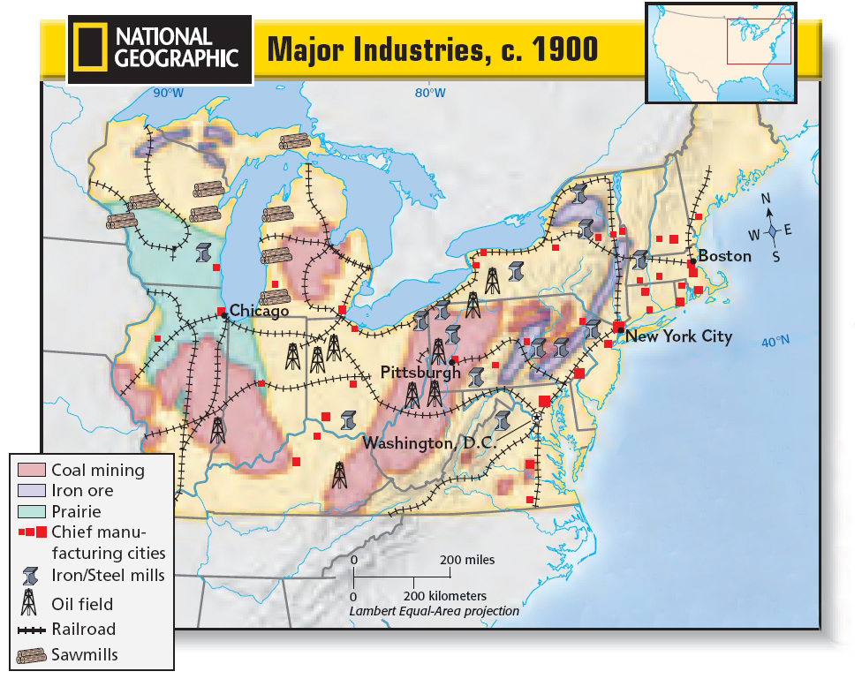
Use the Map above to answer the following questions.
- Where were most industrial cities in the Northeast located?

- What natural resources contributed to making Pittsburgh, Pennsylvania a major steel center?

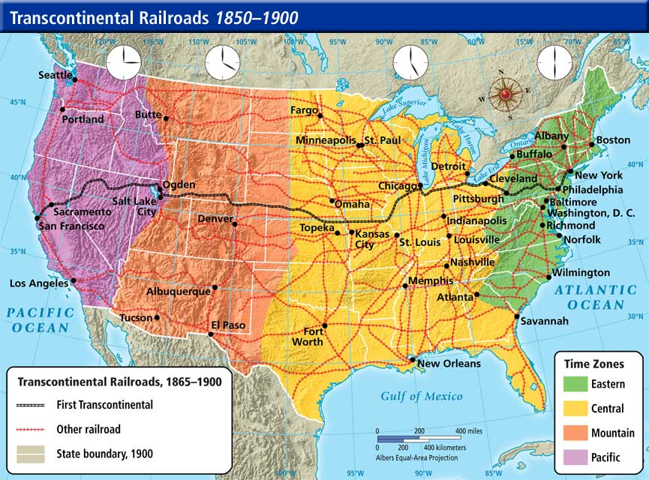
Using the map above answer the following questions.
- What part of the United States saw the greatest expansion in rail lines by 1900?

- Which major cities did the First Transcontinental railroad run through? List them.

Use the picture of before and after to answer the question.
