WARM UP LESSON 3: TOPIC 2 INDUSTRIALIZATION
Use the chart below to answer question 12 only.
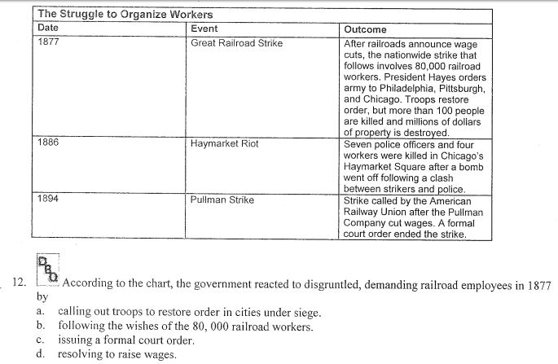

Asnwer the question next to the picture using the informantion in the political cartoon.

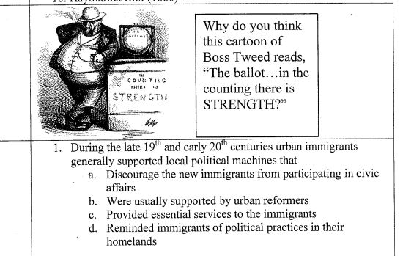

Answer the two questions below using the diagrams.

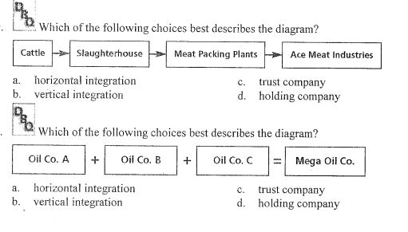

Answer the three questions below using the charts provided.
