Warm Up Topic 1 Articles of Confederation
Read the text and answer the questions that follow.
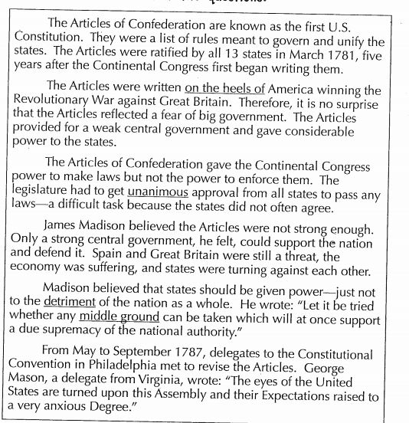

- Use context clues to define each of the underlined words in the text. Next use a dictionary to define the words.

- On the heels of
- Unanimous
- Detriment
- Middle ground

- List three problems regarding the rules of the Articles of Confederation.
1.________________________________________
2.________________________________________
3.________________________________________
3. Explain the need to replace the Articles of Confederation with regard to your answers above.

Read the quotations. Then explain what each quote means in your own words.

- “Let it be tried whether any middle ground can be taken which will at once support a due supremacy of the national authority”.
- “The eyes of the United States are turned upon this Assembly and their Expectations raised to a very anxious Degree”.

