WARM UP EARLY INDEPENDENCE
Read the text and answer the questions that follow:
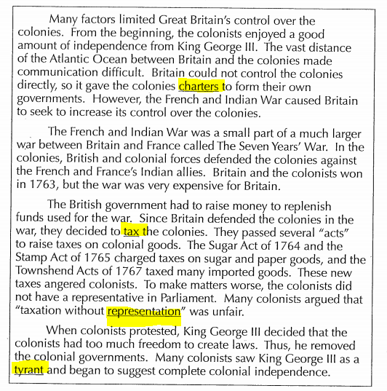
- Use context clues to figure out the meaning of the highlighted words: What do you think the word means? Write your answer on the line.

- Charter:____________________________________
- Tax:______________________________________
- Representation:_____________________________
- Tyrant:____________________________________

- List the factors that caused the colonists to have some independence from Britain before the French and Indian War?

- Why did the British Government think it necessary to tax the colonies?

- In your own words, explain “taxation without representation”.

- What event caused many colonists to see King George II as a tyrant?

