Warm Up Topic 1: Federalists v. Antifederalists
Read the text , complete the graphic organizer and answer the questions.

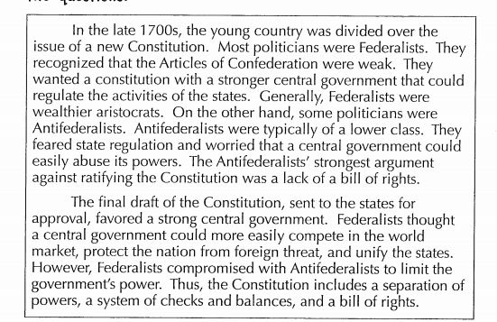

FEDERALISTS:

vs
ANTIFEDERALISTS:

- Why did the Antifederalists fear a strong central government?

- According to the text, what benefits come from having a strong central government? Predict what problems might arise without a strong central government.
- Why were Antifederalists promoters of “states’ rights”?
- Use an online resource to research “states’ rights” today, are these issues still relevant today?

