Look at the cartoon and read the text. Answer the questions that follow and complete the writing prompt. 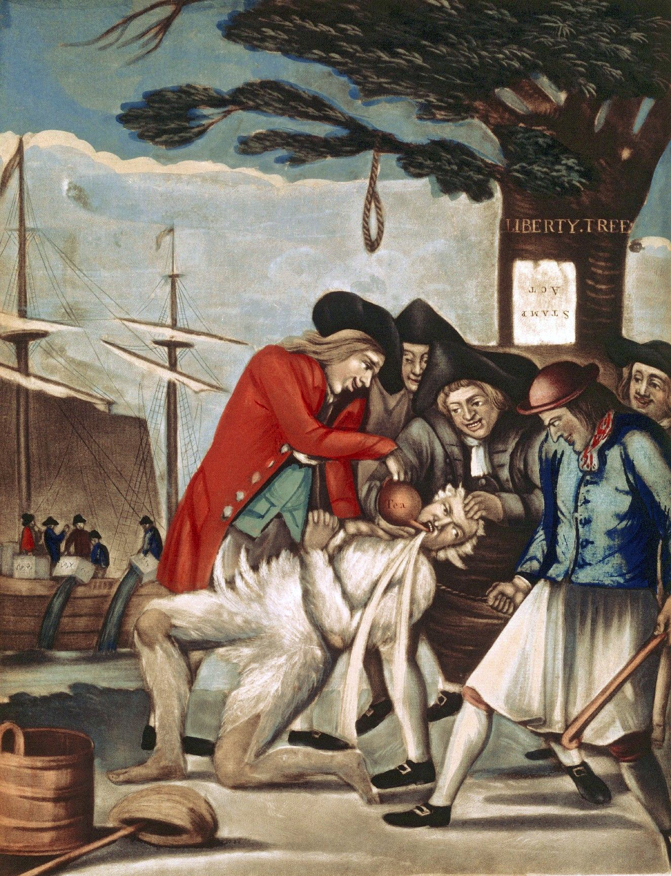
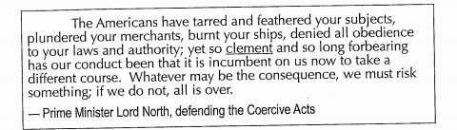

Look at the political cartoon and answer the questions.
- From looking at the political cartoon: The Title is “Paying the Excise-Man” What do you think the word excise means? Next, look the word up in a dictionary? How close were you to the definition?

- Explain what is happening in this cartoon? Use an online resource and describe the process of “tarring and feathering”. ____________________________________________________________________________________________________________________________________________________________
- What can you infer about the cartoonist’s opinion of British taxes?
- What is the message of this political cartoon? What symbols or details do you see in the cartoon that convey the message?
Read the passage from Lord North to King George III ,to answer the following questions.
- What is Lord North’s opinion of American colonists? Provided evidence from the text.
- Use context clues to define the world clement. Next use a dictionary to define the word. How do the British view their actions toward the colonists?
- What is the tone of Lord North’s message to King George III? How do you know?
Compare and contrast the cartoon and the text.
- Explain how the cartoon and text differ in point of view.
Writing Prompt: Imagine you are the British “Excise-Man” in the cartoon. Write a short response explaining your point of view. Include in your response your reaction to being “tarred and feathered.”

