Warm Up topic 1 “The Great Compromise”

Read the text and answer the questions.

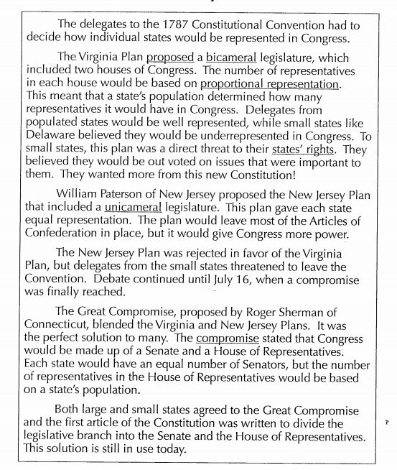

Vocabulary: Use context clues to define the underlined words in the text.
- Proposed
- Bicameral
- Proportional representation
- States’ rights
- Unicameral
- Compromise
- Does your definition match the actual definition given in the dictionary?

- What were the two plans proposed? Explain each plan.

- What was the final compromise?

- How would our government be different if the Great Compromise had not been implemented?

