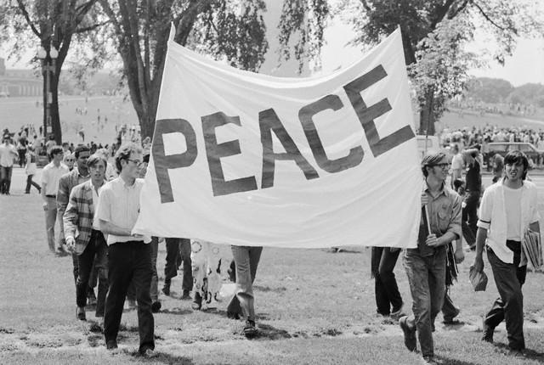

IMAGE A: In two or three sentences, describe the image in terms of people, activities, objects and places.

__________________________________________________________________________________________________________________________________________________________________________________________________________________________________________________________________________________________________________________________________________________________________________________________________________________________________________________________________________________________________________________________________________________________________________________________________________________

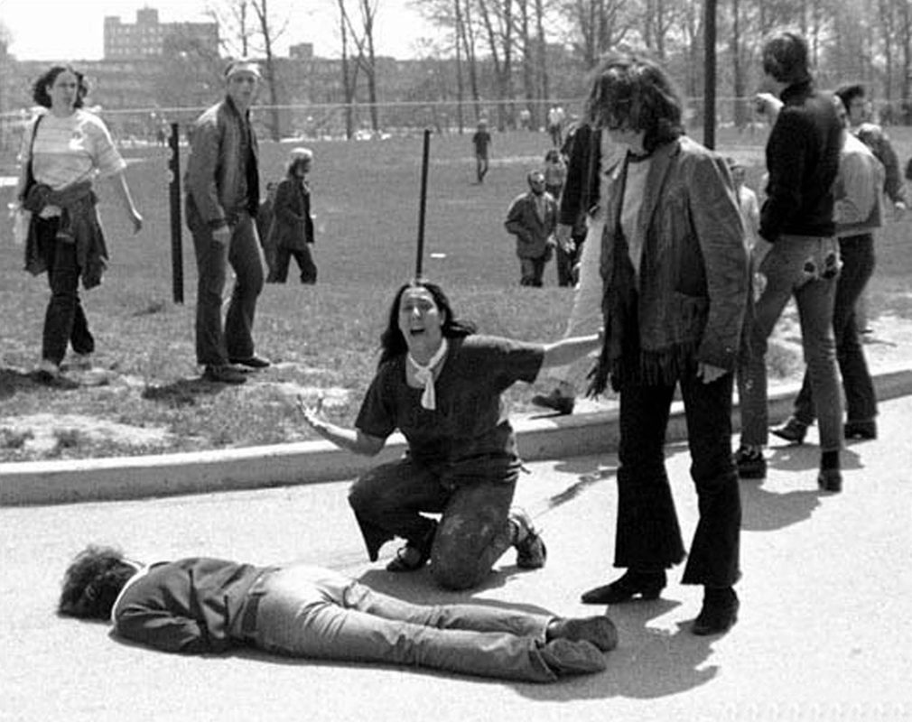

IMAGE B: in two or three sentences, describe the image in terms of people, activities, objects and places.

___________________________________________________________________________________________________________________________________________________________________________________________________________________________________________________________________________________________________________________________________________________________________________________________________________________________________________________________________________________________________________________________________________________________________________________________________________________
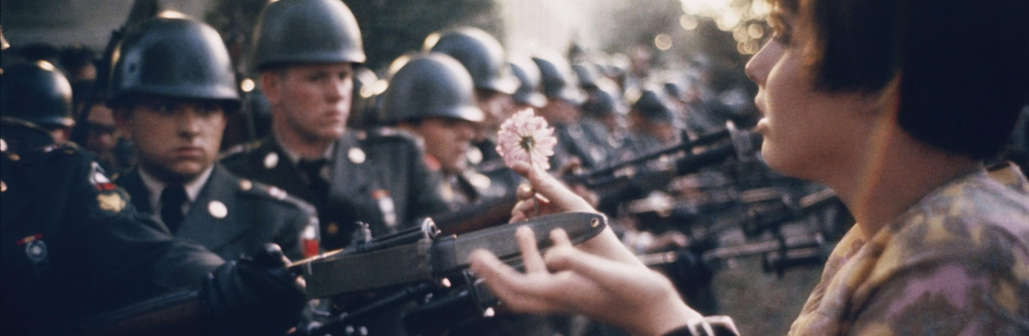

IMAGE C: In two to three sentences describe the image in terms of people, activities, objects and places.

__________________________________________________________________________________________________________________________________________________________________________________________________________________________________________________________________________________________________________________________________________________________________________________________________________________________________________________________________________________________________________________________________________________________________________________________________________________

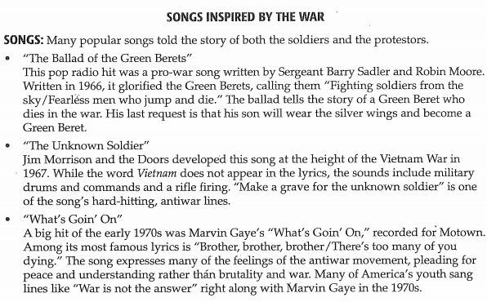

The war in Vietnam inspired many reactions, some of which found their way into the “hits” of popular culture. Read about the songs above and answer the questions below.

- Which song above, has a different message than the others?

- How do the songs above relate to the images you described in the earlier part of the lesson?

- In what ways do you think the songs listed above affected the attitudes toward war of those living in the Vietnam era?

- What events do you think influenced both the songwriters and the listeners in choosing their lyrics?

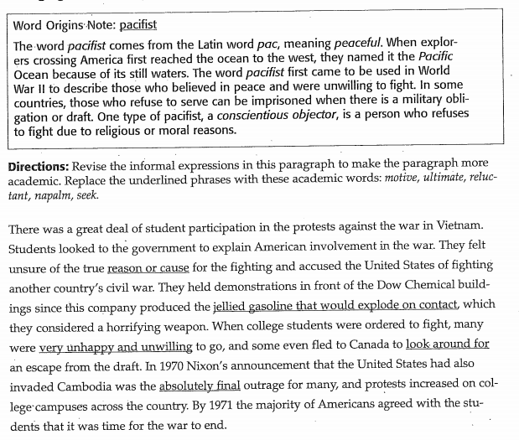

WORD CHOICES: motive , ultimate, reluctant, napalm, seek.
- Replace reason or cause with_________________

- Replace jellied gasoline that would explode on contact with ______________________

- Replace very unhappy and unwilling with______________________________

- Replace look around for with_____________________________

- Replace absolutely final with__________________________

